|  |  |
| --- | --- |
| **Type:** | Defect |
| **ID** | BCR-001 |
| **Title** | Lancia Make – Stratos Model web page is unresponsive |
| **Status:** | New |
| **Project:** | Buggy Cars Rating |
| **Component/s:** | Overall Rating |
| **Affects Version/s:** | Release 1 |
| **Reporter:** | Viswanadh Eleswarapu |
| **Environment:** | Test environment - https://buggy.justtestit.org/ |
| **Severity** | Critical |
| **Priority** | High |
| **Created** | 22/08/2021 |
| **Test Data** | * Login credentials used for testing – login1/Login@12345 * Lancia make - Stratos model |
| **Steps to Recreate** | * Login to Buggy Cars Rating webpage with login1/ Login@12345 * Click Overall Rating image on the home page * Cars rating page opens * Navigate to Lancia make - Stratos model * Click on the image presented against Lancia make - Stratos model |
| **Expected Results** | * Web page opens with Lancia Make – Stratos model details * User can navigate to home page and perform other actions on the page |
| **Actual Results** | * Web page opens with empty specification details and model image is not presented * Click on “Buggy Rating” link to navigate to home page * Home page is not presented and webpage becomes empty * Browser is unresponsive and user can not navigate back using back arrow |

**Test Evidences:**

Lancia-Stratos model on overall rating page:

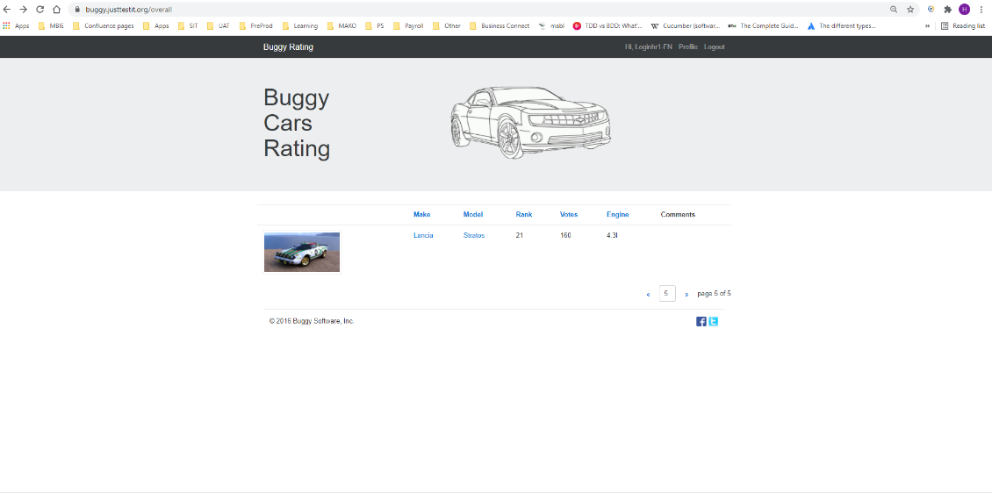

After clicking on the image

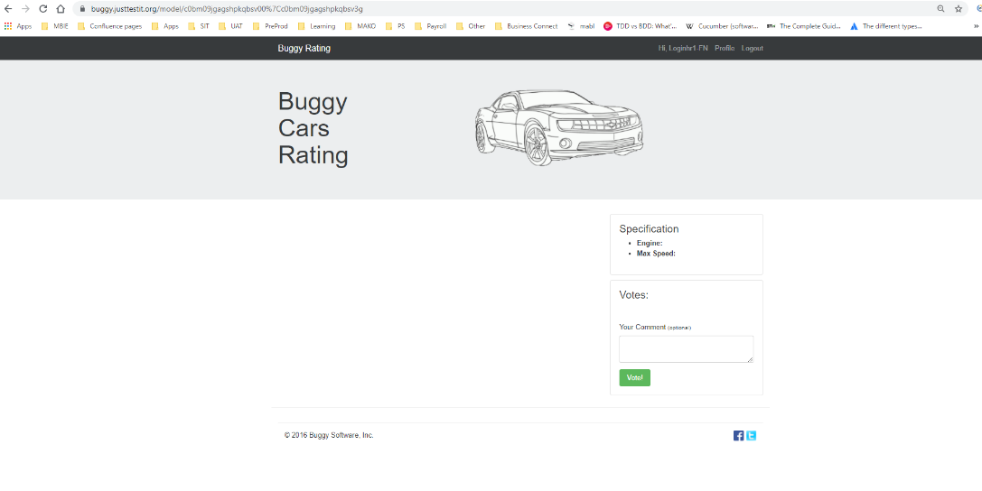

After clicking on the link – Buggy Rating

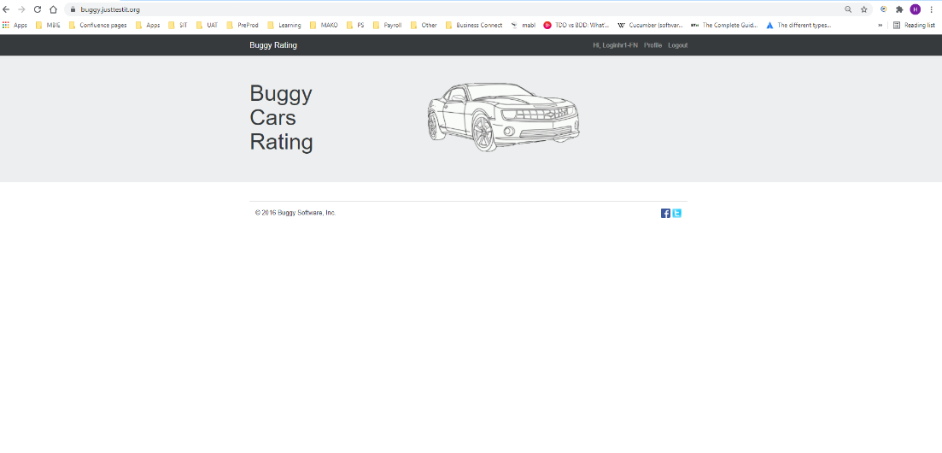

|  |  |
| --- | --- |
| **Type:** | Defect |
| **ID** | BCR-002 |
| **Title** | Cars ranking is incorrect when two cars have same number of votes |
| **Status:** | New |
| **Project:** | Buggy Cars Rating |
| **Component/s:** | Overall Rating |
| **Affects Version/s:** | Release 1 |
| **Reporter:** | Viswanadh Eleswarapu |
| **Environment:** | Test environment - https://buggy.justtestit.org/ |
| **Severity** | Critical |
| **Priority** | High |
| **Created** | 22/08/2021 |
| **Test Data** | * Login credentials used for testing – login1/Login@12345 * Lamborghini make - Countach model * Lamborghini make - Gallardo model |
| **Steps to Recreate** | * Login to Buggy Cars Rating webpage with login1/ Login@12345 * Click on Overall Rating image on the home page * Cars rating page opens * View cars ranking * Lamborghini Countach has 486 votes and its ranking is 14 * Lamborghini Gallardo has 485 votes and its ranking is 15   Vote to Lamborghini Gallardo so that its voting count is same as Lamborghini Countach   * Click Lamborghini Gallardo – View More option which opens Lamborghini Gallardo page * Click Vote. “Thank you for your vote” message is presented * Navigate back on the browser to see overall rating page * Navigate to the page where Lamborghini Gallardo and Lamborghini Countach cars are presented * View votes and rank presented for both cars |
| **Expected Results** | * When voting for two cars is same, their ranking is same |
| **Actual Results** | * Lamborghini Gallardo has 486 votes and its ranking is moved to 14 * Lamborghini Countach has 486 votes and its ranking is moved to 15 |

**Test Evidences:**

Before voting for Lamborghini Gallardo:

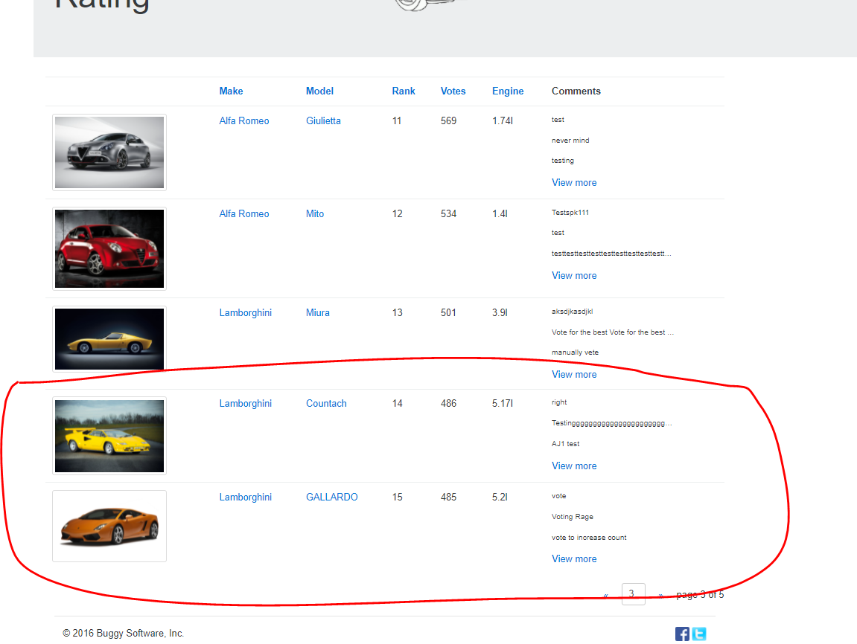

When both cars have same number of votes:

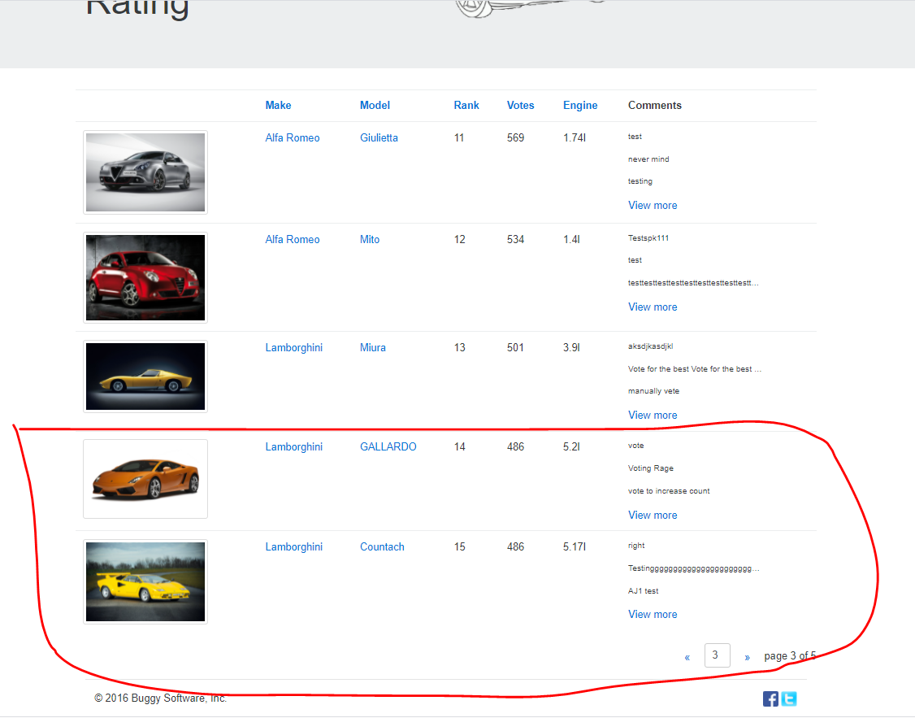

|  |  |
| --- | --- |
| **Type:** | Defect |
| **ID** | BCR-003 |
| **Title** | Buggy Rating link is broken from Popular Make page |
| **Status:** | New |
| **Project:** | Buggy Cars Rating |
| **Component/s:** | Popular Make |
| **Affects Version/s:** | Release 1 |
| **Reporter:** | Viswanadh Eleswarapu |
| **Environment:** | Test environment - https://buggy.justtestit.org/ |
| **Severity** | Critical |
| **Priority** | High |
| **Created** | 22/08/2021 |
| **Test Data** | * Login credentials used for testing – login1/Login@12345   Lamborghini make - Diablo model |
| **Steps to Recreate** | * Login to Buggy Cars Rating webpage with login1/ Login@12345 * Click on Popular Make image on the home page * Lamborghini Models page opens * Click “Buggy Rating” link to navigate to the home page |
| **Expected Results** | * Buggy Cars Rating home page is presented |
| **Actual Results** | * Home page is not presented * Lamborghini Models page remains on the frontend |

**Test evidences:**

Lamborghini model page after clicking on the link – Buggy Rating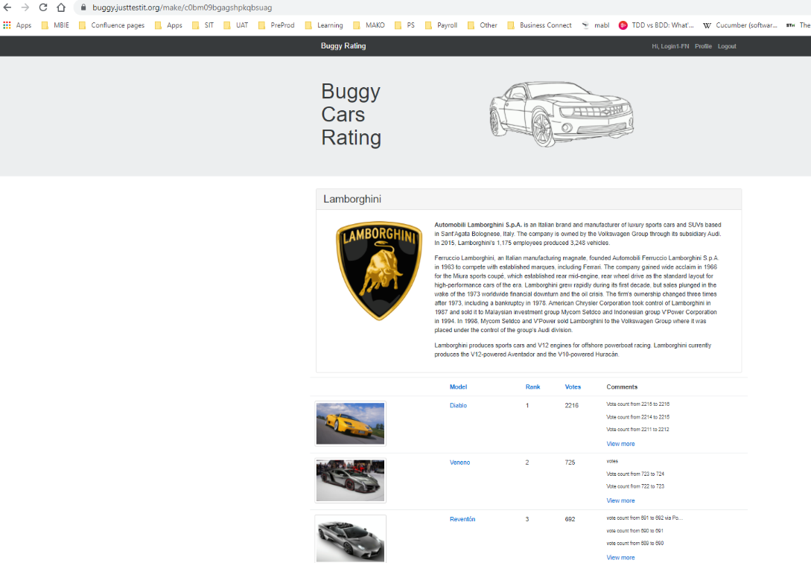

**Apart from defects listed above, other defects that exist are as below:**

**ID: BCR-004**

**Defect Title: From Profile page, selecting logout does not present home page**

Steps to recreate:

* User is navigated to profile page
* Click on Logout

Expected Results:

* User is logged out.
* Since profile page has user specific information, it is expected that when user is logged out, profile page is closed

Actual Results:

* User is logged out but profile page is still open.

**ID: BCR-005**

**Defect Title: Incorrect specification for Lamborghini Diablo**

Steps to recreate:

* User is navigated to popular Model -> Lamborghini Diablo Page
* View specification

Expected Results:

* Correct specification is presented

Actual Results:

* Incorrect max.speed. Max speed :25km/h

**ID: BCR-006**

**Defect Title: Incorrect page counter on overall rating page**

Steps to recreate:

* Open Buggy Cars Rating webpage
* Click on Overall rating image
* On Overall Rating page , keep clicking on symbol >> to navigate to next page

Expected Results:

* Upon reaching last page(5), navigation to the next page is disabled

Actual Results:

* User can navigate to empty pages after page 5

**ID: BCR-007**

**Defect Title: Incorrect sorting order on Rank**

Steps to recreate:

* Open Buggy Cars Rating webpage
* Click on Overall rating image
* On Overall Rating page , click on Rank to sort the table on Rank

Expected Results:

* The table displayed is sorted on Rank.
* Rank order should be ascending

Actual Results:

* Sorting on Rank is not correct. Rank 10, 11,12 are displayed after 1

**ID: BCR-008**

**Defect Title: Missing Image for Lancia make Ypsilon model**

Steps to recreate:

* Open Buggy Cars Rating webpage
* Click on Overall rating image
* On Overall Rating page, view images

Expected Results:

* All Make and Models have corresponding Image

Actual Results:

* Lancia make Ypsilon model does not have image

**ID: BCR-009**

**Defect Title: Issues with sorting on Popular make page**

Steps to recreate:

* Open Buggy Cars Rating webpage
* Click on Popular Make image
* On Popular Make page, click on links Model, Rank and Votes to view sorting order on respective columns

Expected Results:

* Sorting on respective columns is ascending

Actual Results:

* Click on Model link – Sorting is not occurring
* Click on Rank Link – sorting is not occurring
* Click on Votes – Sorting is occurring but the order is not correct . Shows 174,2208,686

**ID: BCR-010**

**Defect Title: After Registration is successful, user should be presented with Login screen or should be taken back to the home page**

Steps to recreate:

* Open Buggy Cars Rating webpage
* Click on Registration
* Complete registration

Expected Results:

* “Registration is successful” message is presented
* User is taken to login page or home page

Actual Results:

* “Registration is successful” message is presented but still registration form is presented.

**ID: BCR-011**

**Defect Title: Registration is successful, when First name started with special character and Last name started with a number**

Steps to recreate:

* Open Buggy Cars Rating webpage
* Click on Registration
* Enter “@First” in First Name field and “1Last” in last name field

Expected Results:

* First Name and Last name fields should not start with Special characters or numbers

Actual Results:

* Registration is successful

**ID: BCR-012**

**Defect Title: While registering, when Last name field is empty, error presented is “First Name is Required”**

Steps to recreate:

* Open Buggy Cars Rating webpage
* Click on Registration
* Do not enter Last Name field and press Enter

Expected Results:

* Error message “**Last** Name is required” is presented

Actual Results:

* Error message “**First** Name is required” is presented

**ID: BCR-013**

**Defect Title: While registering, when three characters are entered in password field, error message presented is not user friendly**

Steps to recreate:

* Open Buggy Cars Rating webpage
* Click on Registration
* Enter three characters in password field

Expected Results:

* Error message presented is clear and understandable to the end user

Actual Results:

* Error message presented is, “minimum field size of 6 SignUpInput.password”. Instead of SignUpInput.password, password would be more clear

**ID: BCR-014**

**Defect Title: While registering, when six characters are entered in password field, error message is conflicting**

Steps to recreate:

* Open Buggy Cars Rating webpage
* Click on Registration
* Enter six characters in password field

Expected Results:

* Password should be accepted
* Error message is not presented when six characters are allowed

Actual Results:

* Error message presented is, “minimum field size of 6 SignUpInput.password”.
* Password is not accepted

**ID: BCR-015**

**Defect Title: While registering, all errors related to password acceptance should be displayed at once**

Steps to recreate:

* Open Buggy Cars Rating webpage
* Click on Registration
* Enter eight characters-lower case in password field

Expected Results:

* Accepted Password Policy should be presented to the user in the error, when user missed one rule in the policy so that the end user can choose valid password in the next attempt itself.

Actual Results:

* Depending on what is being entered in Password field, error messages are shown one after the other